**Biology**

**Sarah Zein-EL-Abdin**

**2022-2023**

**Course Description and Objectives**

This subject is designed to provide a general background for the understanding of the science of Biology. This course develops an appreciation of the beauty of life from its simplest composition at the molecular level to the global spectrum of complex ecological issues. This course also It also deals with the basic principles and processes in the study of biology. It covers life processes and interactions at the cellular, organism, population, and ecosystem levels.

**Textbook**

Miller & Levine Biology

**Unit/Concept Names**

Unit 0 Think Like a scientist

Unit 1 Cell Structure & Transport

Unit 2 Cellular Processes

**Major Course Projects and Instructional Activities**

At least one project will be assigned each grading period. This will be an extension or enrichment of the concepts discussed. Students will have 1 to 3 weeks to complete each project depending on the complexity of the task. Some tasks and/or projects will be completed in class (specifically the unit culminating tasks – these MUST be completed in class only).

**Course Assessment Plan**

Students will receive a variety of assignments designed to enhance their learning. If a student is absent, the student is responsible for the missed assignment. Students who have an excused absence will be allowed five days to turn in the missed assignment. No work will be accepted after five days.

**Evaluation (Schoolwide Grading Policy)**

* *Minor Grades* = 60% (quizzes, labs, and other graded assignments to assess certain standards in a

unit of study)

* *Major Grade*s = 40% (unit tests, essays, research papers, project-based assignments, special projects, and other culminating assessments to measure mastery of standards that comprise a unit of study)

**Classroom Procedures & Expectations**

The overarching expectation in this class is RESPECT: respect for yourself, respect for other students, respect for the teacher/or any individual in authority, and respect for any guests that may enter our class. Although this encompasses all other expectations, I will outline several others for the sake of clarity.

1. Be on Time!
2. Begin the Warmup as soon as you come to class
3. Remain SEATED and PREPARED at all times.
4. No cell phone, foods, or drinks in class
5. Every student is responsible for helping to maintain a clean, safe learning environment. Your area must remain CLEAN at all times. The floor should be clear of trash, paper, and personal belongings.
6. Adhere to all policies, rules, and regulations outlined in the student handbook, Lucy Laney High School’s Norms.
7. Ask if you need help
8. DO Your BEST

**Electronic device policy**:

1. Students are required to bring their school laptops to be used in class
2. Cell phones may not be used in class.

**Course Materials**

* 3” 3-ring Binder

* Loose Leaf Paper * 1 Package of Dividers (5 Total)

* Pencils

* Handheld pencil sharpener * Highlighters

* Loose Leaf Paper

* Coloring Utensils (crayons, coloring pencil, or markers)

Donations appreciated for the following (optional):

**\***Copy Paper * Hand Sanitizer *Dry Erase Markers *Kleenex * Disinfectant Wipes

**Resources:**

**Note: All course material will be posted on Canvas, make sure to check canvas every day.**

Recommended resources

Biology Definition and Dictionary app

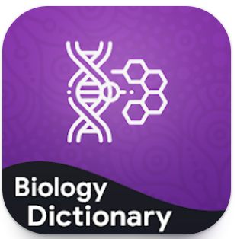

Cell Biology 101

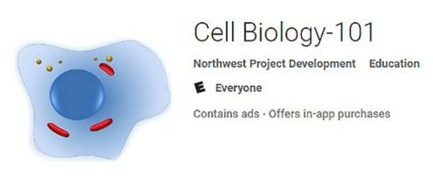

# Cell World

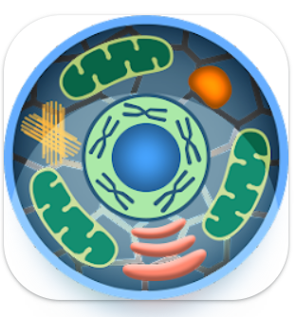

**Modes of Communication:**

Email: zeinesa@boe.richmond.k12.ga.us

Remind messages: Text the message @zeinbi to the number 81010